FOURTH GRADE SYLLABUS

Thomas E. Bowe School

2019-2020

**Welcome to Fourth Grade at Bowe School!**

We are confident that the upcoming school year will be challenging, fun, and rewarding. Below are the educational requirements, behavioral expectations, and parental expectations for all fourth grade students at Bowe School.

**Educational Requirements:**

The fourth grade teachers expect 100% effort from every student each day! We encourage and expect students to become actively involved in their classroom and become fully involved in their educational career. We expect active involvement and participation starting in September and continuing through June.

**THE REQUIREMENTS ARE AS FOLLOWS:**

1. Students are responsible for coming to class prepared every day. Items needed can be found on the attached Supply List. Students are also expected to fill in their Planners daily. They will receive a planner from the school on the first day.

2. All work must be legibly and neatly written or it will be returned to be redone.

3. All work to be handed in must be completed on loose-leaf paper unless otherwise noted by your teacher and **must** have the proper school heading at the top of the page.

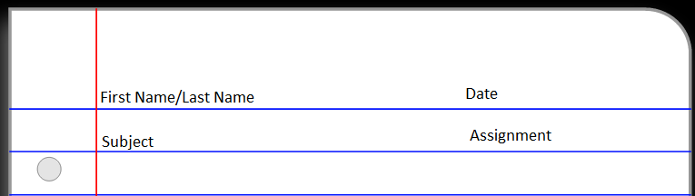

**(EXAMPLE HEADING)**

**BEHAVIORAL EXPECTATIONS**

All students are expected to follow all school and class rules as outlined in the Parent/Student Handbook. Your fourth grade year at Bowe School will be one of your most memorable school years. As a fourth grader you have the opportunity to participate in many wonderful activities. However, your participation in activities is not guaranteed. In order to participate in activities you must meet the following eligibility requirements. For example:

* Discipline referrals/detentions may keep you from participating in our many fun field trips. Parents may be required to chaperone students if necessary.
* Consistently submitting incomplete assignments, including homework and class work, may result in removal from a trip or activity.
* Students are expected to show respect for teachers and other students at all times.

**PARENTAL EXPECTATIONS**

All research suggests that when parents are involved in their child’s education it will result in higher student achievement. Parents are also encouraged to become involved in their child’s educational experience by volunteering for different grade level and school-wide activities.

* Every student will be given a homework planner on the first day of school. This planner is used to communicate homework assignments, upcoming events, and important dates.
* Please check and sign your child’s planner each night
* Assist your child as needed to develop fully as a Bowe School student by:
* Assisting with homework
* Supporting our school rules
* Communicating openly with teachers
* Spending time with your child reading and developing grade level skills such as fact knowledge.

**~REMINDER~**

Don’t forget to read!

The Summer Reading Requirements are going home with report cards!

We are looking forward to a **GREAT** year!

**The Fourth Grade Teaching Team**

**Thomas E. Bowe School**

A copy of this syllabus can be found on our school website

<http://www.glassboroschools.us/Domain/210>

**4th Grade Supply List**

|  |
| --- |
| * + Expo markers   + Expo eraser   + Red Pens   + Sharpened Pencils (Ticonderoga)   + Erasers   + Highlighters   + Crayons or colored pencils (8,12,24pk)   + Soft pencil case   + Post-it Notes   + Books for silent reading   + Clear plastic protractor   + Scissors   + 2 large glue sticks   + 2 pairs of earbuds |

**Classroom Wish List**

* Large bottles of hand sanitizer
* Tissues
* Paper towels
* Clorox wipes
* Expo Markers to share
* Ziploc Bags

Supplies may need to be replenished throughout the year.